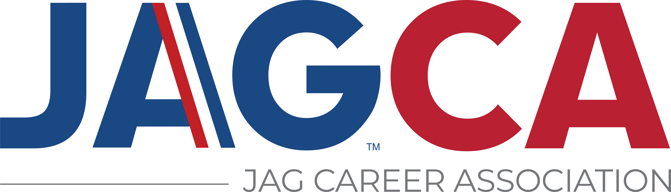
JAG Career Association
Delegate Conduct Code

A good reputation enables members to take pride in their organization and National JAG Career Association (JAGCA) members have an excellent reputation. Your conduct at any JAGCA conference or function should make a positive contribution to the reputation that has been established the JAGCA.

- My behavior at all times will reflect positively on me, my school, my state, Jobs for America’s Graduates and the JAG Career Association.

- Conduct is the responsibility of the official chaperone. I will keep my chaperone informed of my activities and whereabouts at all times.

- I will attend all leadership sessions and other scheduled conference activities. I will be prompt and show respect to those in the audience and on stage.

- I will report any accidents, injuries or illnesses to my chaperone or JAG staff member immediately.

- I will observe the designated curfew. Curfew is described as being in my assigned room by the designated hour.

- If I steal or vandalize the hotel or others’ property, I and/or my parents/guardian will pay any and all damages.

- I will not purchase, consume or be under the influence of alcohol or drugs at any time. Violators will be subject to stringent disciplinary action.

- I understand that smoking is not allowed.

- I understand I will be subject to disciplinary action and may be sent home at my own expenses if I disregard the rules. My parents/guardians and my school will be notified.

- I know I am responsible for any incidental charges to the hotel room (long distance calls, movie rentals, etc.) and such charges will be paid upon check-out.

Above are the rules for the National JAGCA that all conference delegates abide by.

______________________________________________________________________________
Delegate Name Delegate Signature Date

